**Regularized Logistic Regression**

We can regularize logistic regression in a similar way that we regularize linear regression. As a result, we can avoid overfitting. The following image shows how the regularized function, displayed by the pink line, is less likely to overfit than the non-regularized function represented by the blue line:

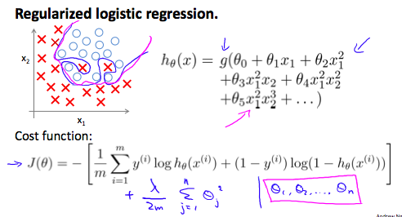

**Cost Function**

Recall that our cost function for logistic regression was:



We can regularize this equation by adding a term to the end:



The second sum, **means to explicitly exclude** the bias term, *θ*0. I.e. the *θ* vector is indexed from 0 to n (holding n+1 values, *θ*0 through *θn*), and this sum explicitly skips *θ*0, by running from 1 to n, skipping 0. Thus, when computing the equation, we should continuously update the two following equations:

